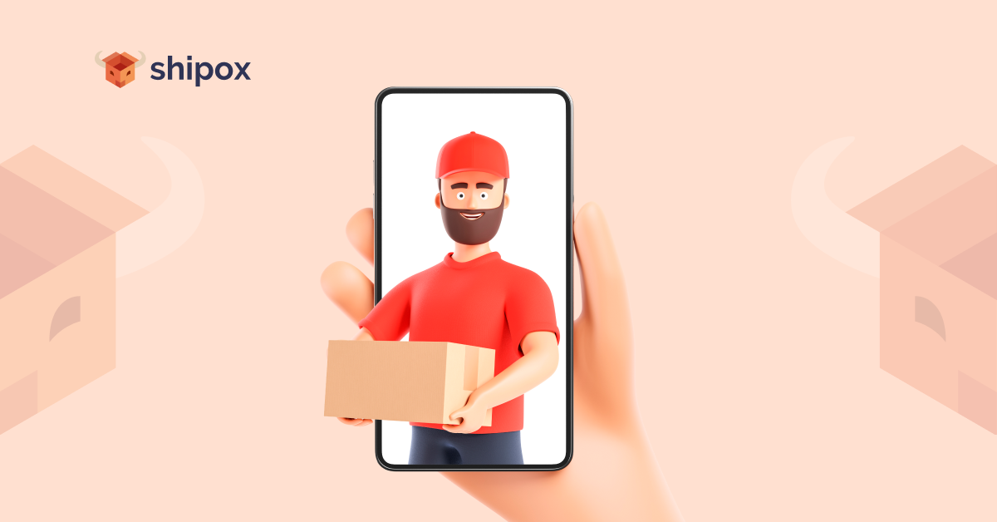

**Best Food Delivery Software**

**What is a Food Delivery Software?**

A [food delivery software](https://en.wikipedia.org/wiki/Online_food_ordering) or a restaurant delivery software is a computer software that provides restaurants and food businesses with the correct tools and ability to manage and market their restaurants’ or business operations successfully. It enables restaurants to enhance food delivery operations, and therefore increase sales, profitability, and clientele.

**What Features Should the Best Food Delivery Management Software Have?**

Online food ordering software or food delivery software offer many different types of features. However, the best of these software must offer all the essential features which are necessary for a successful delivery journey. Here is the list of the features that you should look out for when choosing the best food delivery management software:

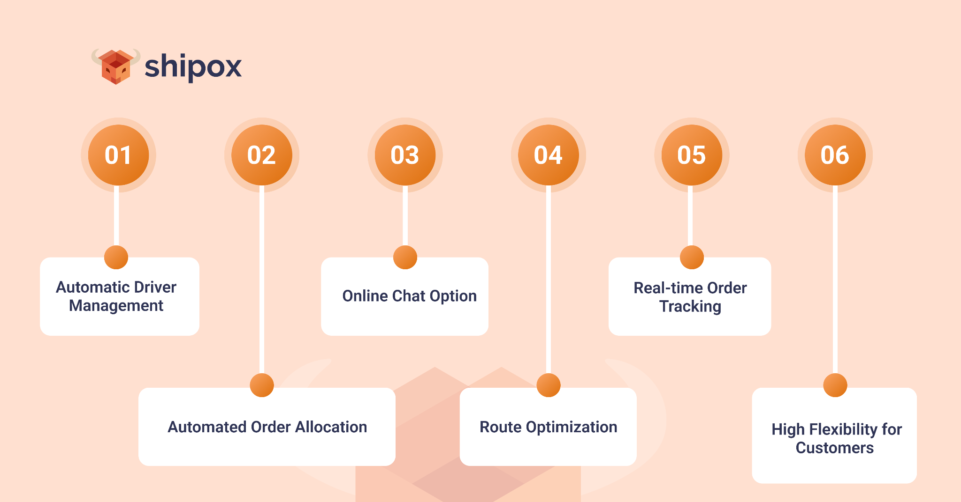

1. **Automatic Driver Management**

This can increase the efficiency of the delivery process by more than 60%. Automatic driver management or fleet management is highly important and it can help to allocate the correct amount of drivers based on the number of orders to be delivered and will make sure to distribute the workload equally among the staff. This will increase managerial efficiency and will help take your food delivery business to new levels of success. It will keep drivers updated and notified, and accountable for their performance during all stages of the delivery cycle.

1. **Automated Order Allocation**

Automated order allocation relieves food businesses of the manual errors and manual burden of allocating orders correctly and effectively. Often, there may be errors regarding wrong information provided for delivery and the allocation of multiple orders to the same person, which can make the delivery journey inefficient and it can create many issues in terms of customer experience. Automation of processes relieves people of this burden and perfects delivery operations.

1. **Online Chat Option**

The best food delivery software such as Shipox will provide users with the ability to use the option of white labeled applications and websites. These will be managed by the food delivery software as a third party, under the name of the food business. It can enable customers to avail live chat and other effective options for communication.

1. **Route Optimization**

Route optimization is one of the most important features needed for a successful delivery process. It provides users with the ability to navigate the most suitable and efficient way for carrying out the delivery process. The best food delivery software will also enable you with the ability to re-route, depending on any unexpected hindrances or obstacles in the original delivery route.

1. **Real-time Order Tracking**

This is also known as real-time visibility and it enables users to track their orders live and get real time updates on where their order is at any given time This helps customers build trust in your brand and increases customer experience. It enables companies and businesses to be aware of the order location to increase accountability and to be able to make any relevant changes upon any mishaps.

1. **High Flexibility for Customers**

Customer experience is greatly enhanced when the delivery management process is flexible and is subject to change as per their requests and demands. If your customer decides to change the time or location of the order delivery at any point of the order cycle, your system must be equipped enough to meet their needs to provide them with utmost convenience that can drive them to order food online from your platform rather than just moving on to the competition or opting for take away or in-house dining at another restaurant.

Shipox is a data-driven **Food** **Delivery Software** that enables its users across a multitude of diverse industries to avail market competitive features and customer support in order to automate and perfect their delivery process. Shipox users are able to increase the efficiency of their delivery process, optimize their costs effectively, and enhance their customer experiences. To learn more, you can [sign up for a quick demo here](https://shipox.com/request-a-demo/).