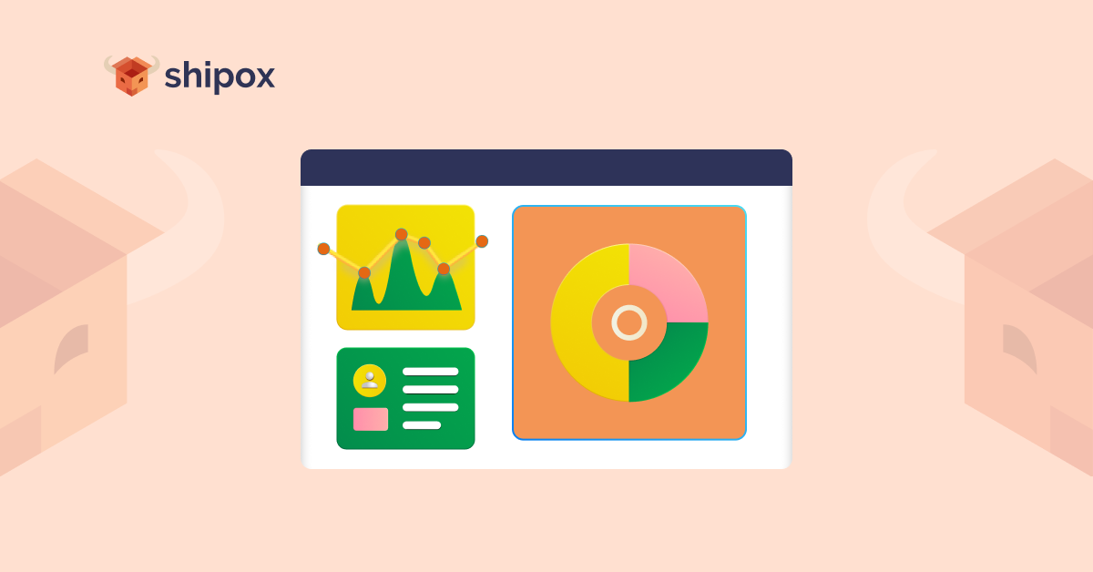**Quick Guide to Shipox Dashboard Analytics**

**What is Dashboard Analytics?**

[Dashboard Analytics](https://support.google.com/analytics/answer/1068216?hl=en#zippy=%2Cin-this-article) is basically a collection of widgets that provide a summarized and concise overview of the key aspects of processes that are crucial for the success of your company. Dashboard analytics comprise many aspects of data analytics that can be viewed and accessed through a single platform. They let you monitor a variety of metrics at the same time, so that you can quickly take a look at the health of your operations and monitor the shortcomings and successes that your company needs to focus on.

**Why is Dashboard Analytics Important for Successful Delivery Management?**

Dashboard analytics is one of the most important features that can play an important role in the success of your delivery operations. Here are some of the advantages that it can have for your business:

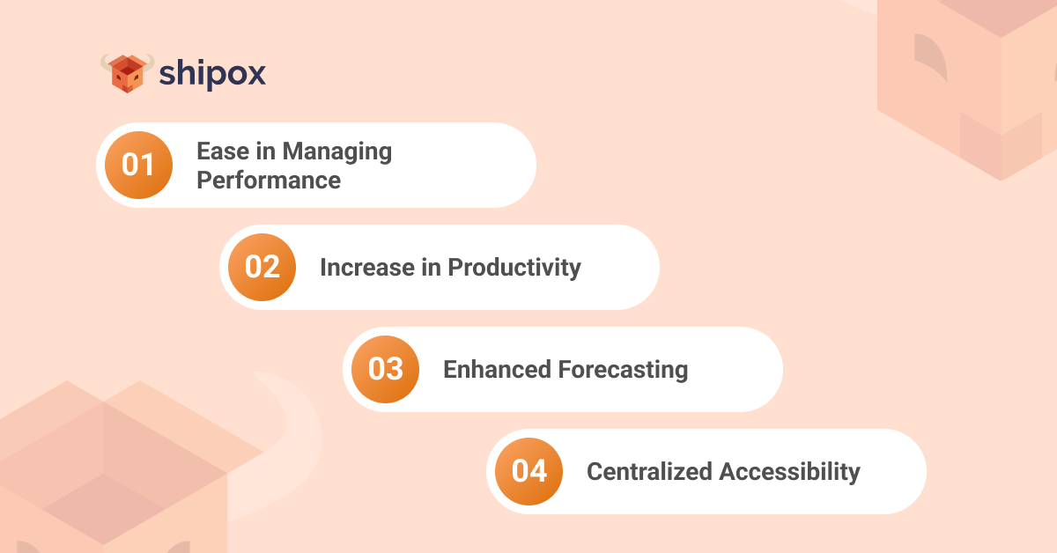

1. **Ease in Managing Performance**

Dashboard analytics has been voted as the key contributor towards making the tasks of operational managers efficient by more than 36%. This is because the overall performance of each sector can be viewed clearly. Managers and relevant departments can monitor the different aspects of performance in order to determine the shortcomings and places where there is need for improvement. A route optimization software or fleet management software can perform best if the results of operations are being clearly reported to the authorities.

1. **Increase in Productivity**

Efficiency has a direct and positive impact on productivity. When managers and staff do not have to spend a lot of time in creating reports and in extracting and analyzing the relevant data, they can have the time and ability to focus on other important aspects, such as increasing productivity and the growth of the business. Dashboard analytics in any logistics management software can provide a detailed view of the hassles in the delivery journey, which can be catered to in order to increase productivity.

1. **Enhanced Forecasting**

Dashboard analytics can enable your business to avail smart predictability of the future. Dashboard analytics can provide you with the complete reports and metrics that you can use to determine different aspects of your company’s performance. It can allow you to forecast which seasons will lead to the most demand for certain products, what the common customer complaints are, what goes wrong in the delivery process, and much more. You can then immediately take the necessary steps to fix any loopholes in the order cycle.

1. **Centralized Accessibility**

A single centralized dashboard that enables users to view all reports in a single place is very convenient and easy to use. It makes the process of monitoring and making plans for improving delivery operations very easy. It also keeps the staff aware of accountability since all reports about their performance are available directly and clearly to the manager. Hence, dashboard analytics has a positive impact on delivery operations.

Shipox is a data-driven **Delivery Management Software** that enables its users across a multitude of diverse industries to avail market competitive features and customer support in order to automate and perfect their delivery process. Shipox users are able to increase the efficiency of their delivery process, optimize their costs effectively, and enhance their customer experiences. To learn more, you can [sign up for a quick demo here](https://shipox.com/request-a-demo/).