

**Is It Smart To Outsource Your Delivery Services**

The modern-day business world is focused on offering the best possible services to customers. For this reason, companies go for outsourcing the operations which they are unable to perform best in-house. More than 37% of operational managers of delivery businesses claimed that they have considered outsourcing their delivery services, and wondered whether this is a feasible solution in terms of business growth and expansion.

The answer is not so simple, but it can be deciphered with some evaluation of the pros and cons of outsourcing delivery services for businesses.

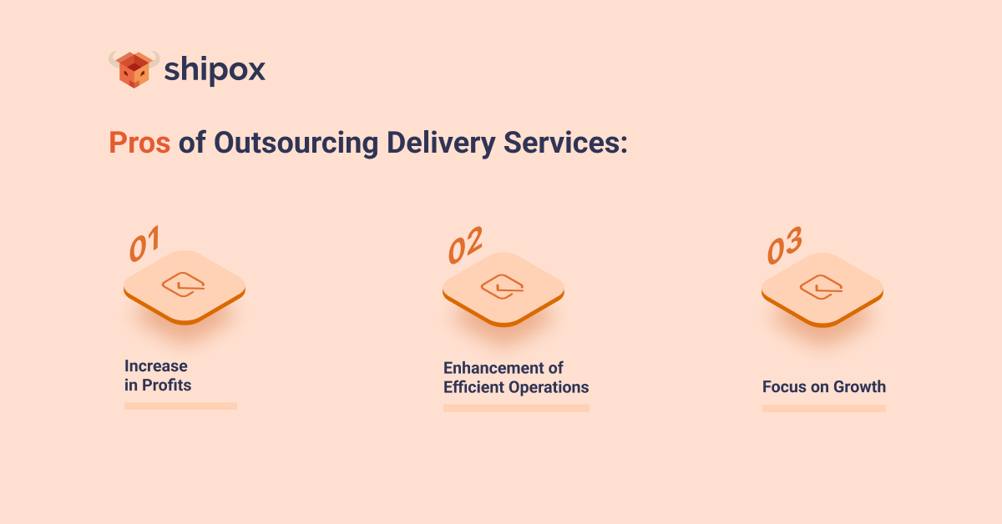

**Pros of Outsourcing Delivery Services:**

1. **Increase in Profits**

[Outsourcing](https://www.investopedia.com/terms/o/outsourcing.asp#:~:text=Outsourcing%20is%20the%20business%20practice,as%20a%20cost%2Dcutting%20measure.) your delivery services can enable you to increase profits because it can automatically reduce a lot of cost that is otherwise spent on the management of the fleet, relevant resources such as drivers and vehicles, fuel, and others. A third-party delivery management company will perform the delivery operations in a more systematic manner and since they manage orders in bulk, they have a lesser cost for performing the same functions. Moreover, well-managed outsourced deliveries will also increase customer loyalty, and hence increase revenue and number of orders.

1. **Enhancement of Efficient Operations**

The company to which you will outsource your delivery operations will most probably have a delivery management system such as Shipox. This will equip the company to carry out all its delivery operations in the best possible manner. They will have route optimization software, and also a fleet management software. This will increase the efficiency of your order by a manifold. Research shows that using a Delivery Management System can increase the efficiency of delivery operations by more than 64%.

1. **Focus on Growth**

If you do not have the capabilities to manage delivery operations in an automated manner, chances are that a lot of your resources and time will be wasted in trying to keep up with the delivery of orders, management of drivers, creating reports, and such tasks. This will mean that your potential is being compromised in the process of carrying out a task which can much simply be performed by another company that is professional in that area. By outsourcing deliveries, your business can focus on other areas of growth and expansion.

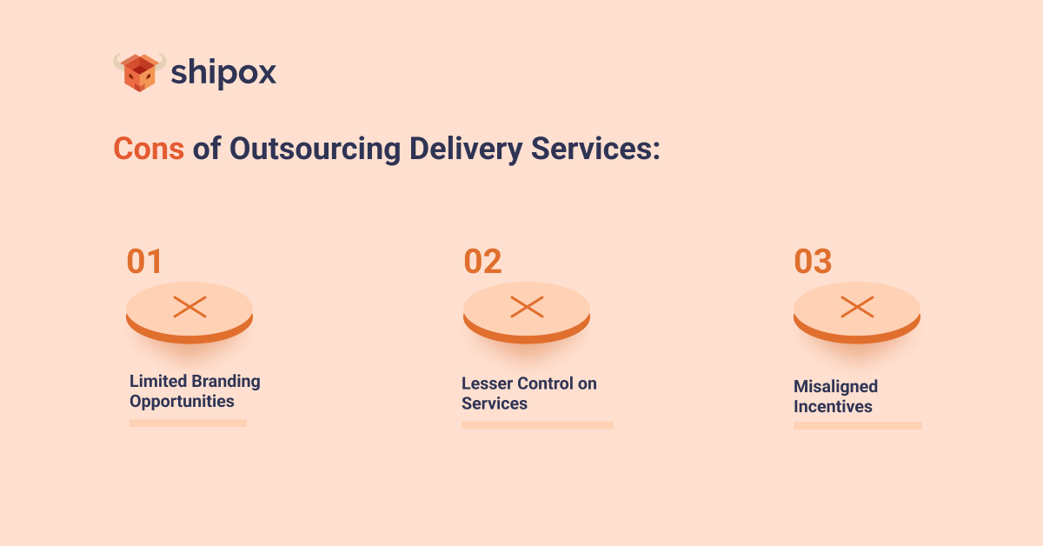

**Cons of Outsourcing Delivery Services:**

1. **Limited Branding Opportunities**

Global food business sector is full of competition and each participant needs to give their best effort in order to make the mark. In such saturated markets, brand identity matters a lot and this can be compromised if the third party that is handling the orders does not allow for white labeling. On the other hand, if the third party does not whitelabel its services, then there are high chances that the branding will be compromised.

1. **Lesser Control on Services**

Outsourcing is always risky. Even if the services are whitelabled, the brand name can be at stake because once the order leaves your warehouse, store, or kitchen, the delivery process and its journey to the customer is no longer in your hands. With outsourcing, you lose control of how the customers are being treated, how the delivery is being managed, and such logistics.

1. **Misaligned Incentives**

The highest probability is that most third-party companies will prioritize their own growth and profits over yours and therefore they might have certain incentives that may not match with those of your business or they might hurt your business as well in different ways. It might not be the most logical decision to outsource your deliveries to a company that does not prioritize your growth as well. Therefore, the decision of which company to choose for outsourcing your deliveries should entirely be yours.

**What is the verdict?**

The data shows that there are pros and cons both attached to outsourcing delivery operations for businesses. It is completely up to the business to keep these pros and cons in mind and decide the best strategy that would align with their goals. It is, however, most sensible that small and medium sized businesses should outsource their delivery services and focus on expansion and growth, while large sized businesses should start focusing on perfecting their in-house delivery services.

Shipox is a data-driven **Delivery Management Software** that enables its users across a multitude of diverse industries to avail market competitive features and customer support in order to automate and perfect their delivery process. Shipox users are able to increase the efficiency of their delivery process, optimize their costs effectively, and enhance their customer experiences. To learn more, you can [sign up for a quick demo here](https://shipox.com/request-a-demo/).